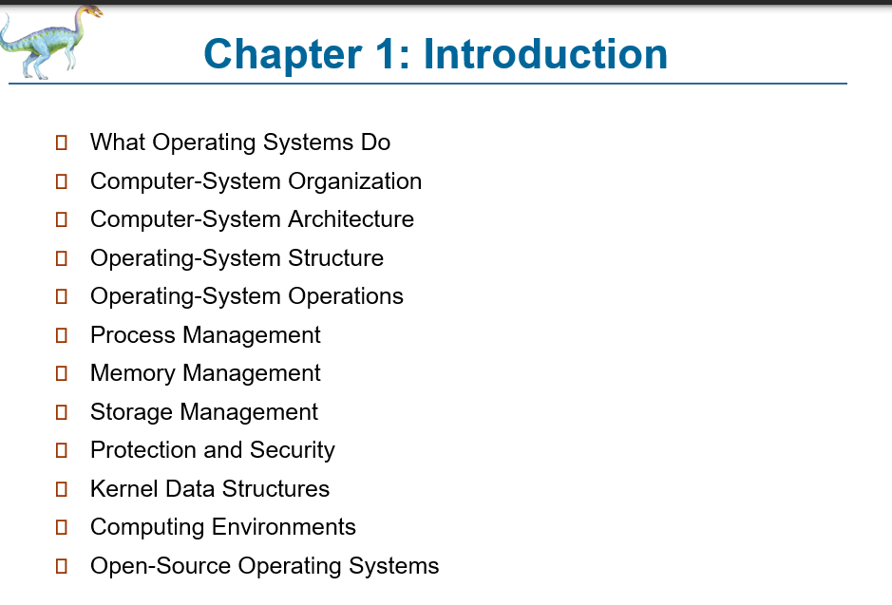

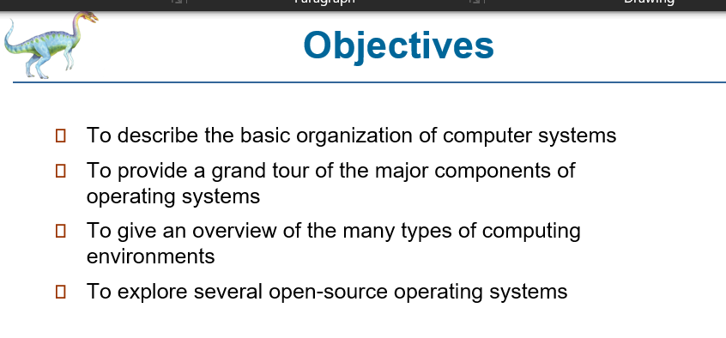

**What's Your Personal Idea When We Say Os?**

* system that manages hardware and software of a smart device

OPERATING SYSTEM IS A PROGRAM THAT SERVES AS INTERMEDIARY BETWEEN A COMPUTER HARDWARE AND THE USER

Hardware devices can only interpret inputs or data via binary and this is ideally not usable for a lot of consumers. Therefore OS servers as the bridge between users and hardware where its software provides a user friendly interface for the user while translating the inputs or interaction of the user to a language that the hardware understands. In short translator siya between user and hardware

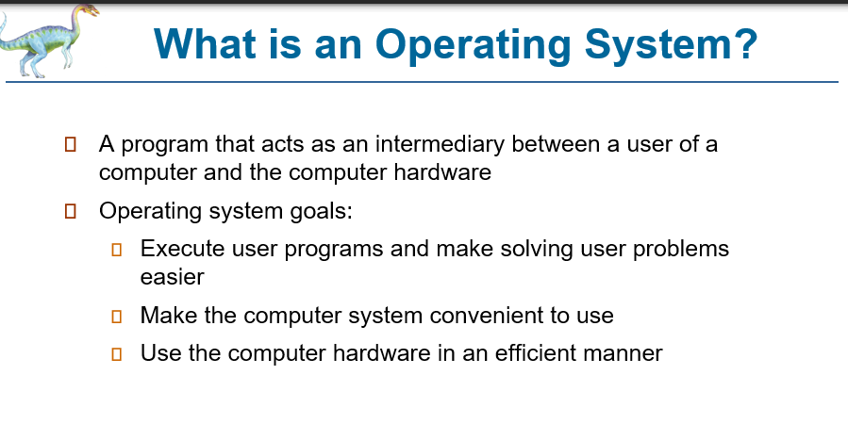

**EXECUTE USER PROGRAMS**

* ...meaning, when you run a program, IT SHOULD FOLLOW OS PROTOCOL or else OS WON'T ALLOW IT TO RUN

**Foundation sng COMPUTER SYSTEM IS ALWAYS 3:**

- first component is... **HARDWARE**

- second is .... **SOFTWARE**...

- and last but not the least is **PEOPLEWARE**

PEOPLEWARE is actually a slang word that refers to all computer users

**Hardware:**

* physical components and usually classified as INPUT or OUTPUT or BOTH

**Software:**

* computer program, classified into, system and application

and the most important system software is the OPERATING SYSTEM sometimes regarded to as the CENTRAL NERVOUS SYSTEM of our computer

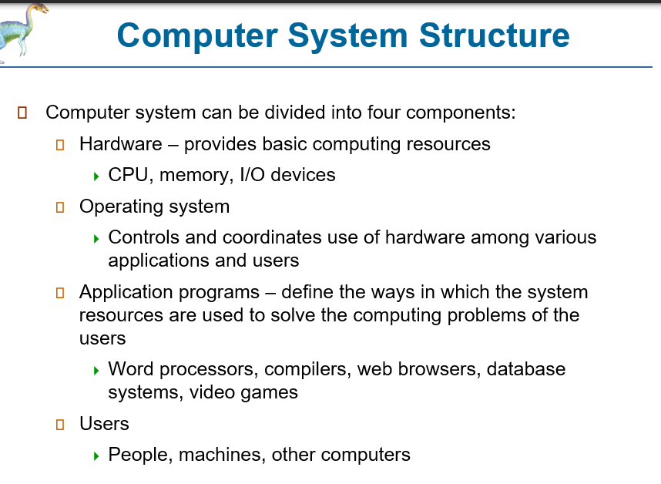

HARDWARE:

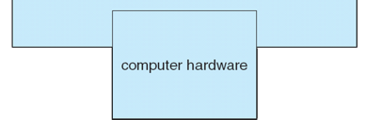

SOFTWARE:

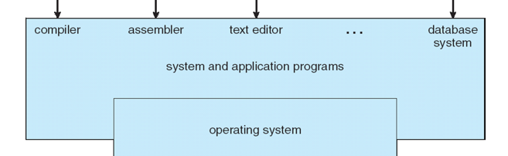

PEOPLEWARE:

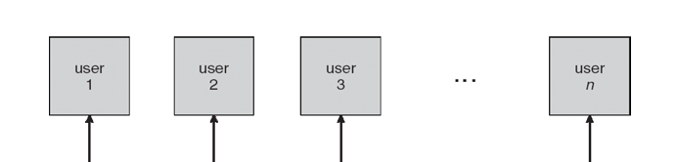

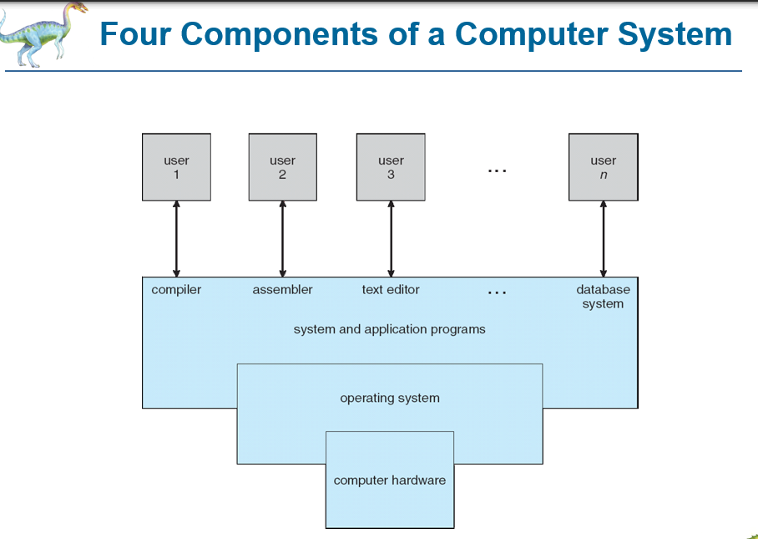

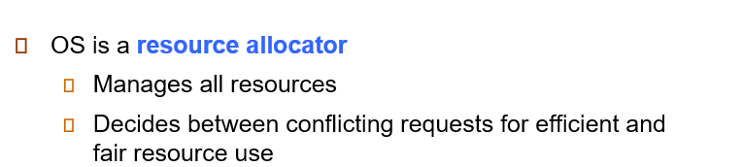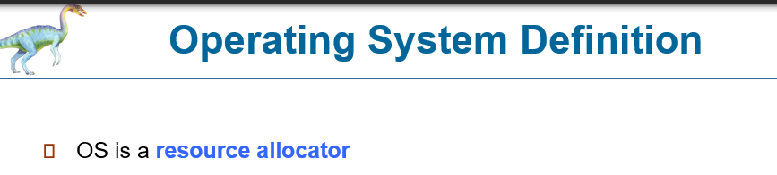



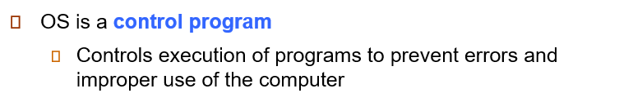

**Question: WHAT WILL HAPPEN TO A PROGRAM IF THERE ARE ILLEGAL REQUESTS AND WILL NOT BE ALLOWED BY THE OS?**

-**first**, there are TYPES OF PROGRAMS WITH ILLEGAL INSTRUCTIONS at the start.....so pag run sng program, TERMINATED DAYON

-**second,** THERE ARE PROGRAMS NGA MAY HIDDEN ILLEGAL CODES LIKE VIRUSES, which RUN at first, but later, execute their illegal activities and WILL BE TERMINATED

so what's the effect? IF THIS IS A DEVICE DRIVER THAT VIOLATES OS PROTOCOL, you will commonly experience BLUE SCREEN

if its a kind of program depending on its violation, a **GPF** usually happens, or **General Protection Fault** and terminates the program

UNDER WORST CASES, the program will freeze and can be killed only by opening the task manager, or again the **BSOD**

- ang Blue Screen of Death is a slang meaning of the acronym

**Device Driver:**

- particular programs that specifically interacts with their designated hardware. OS then manages these drivers

- a device driver is a program that is written for a SPECIFIC DEVICE to allow communication between the device and the OS

- meaning...ang driver ginsulat para sa muna lang nga device kag indi gid pwd sa other devices...kng piliton nyo install, result? another BSOD

- literally, device drivers should be provided by their own manufacturers only

- but lately, THERE ARE THIRD PARTY UTILITIES THAT HOSTS DEVICE DRIVERS....and some DRIVERS ARE INFECTED WITH VIRUSES...one good example is the DRIVERPACK

- as of the moment, using the latest operating system driver update feature is the best way to install and update your drivers

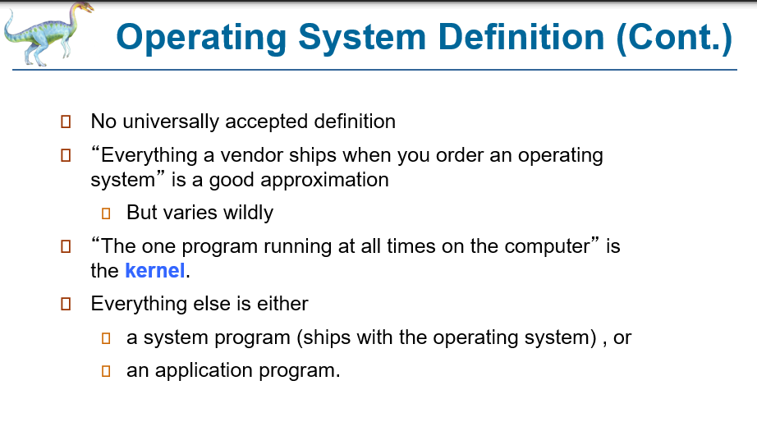

one important component of the OS is its **KERNEL**

This is the most important component which is **TSR** in nature....

- TSR means? **Terminate but Stay Resident** program like your viruses

- they continue residing in computer's memory and activates only when needed

COMPUTER STARTUP

START UP = BOOT UP

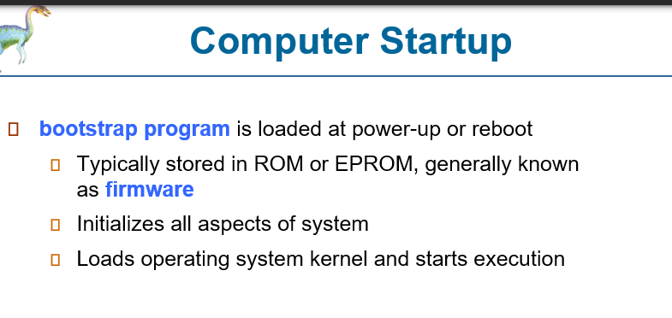

**Bootstrap Program** is activated usually resides in the ROM in a form of a firmware

then......a POST is performed to initialize all aspects of the system

**Power On Self-Test (POST)**

-during the test....ma ask sya....KEYBOARD ARE YOU THERE? ang keyboard will respond by lighting the 3 LEDS, caps lock, num lock, and scroll lock

-pero pag indi na sya mag siga or ma detect, your screen will display, KEYBOARD ERROR OR NO KEYBOARD FOUND...

-then...kng wla problema like your windows...

-ma appear na ang dektop nyo and it's now ready to use....

-sometimes...troubleshooting your computer especially the start up procedure is difficult...UNLESS YOU KNOW THE PROCESSES undergone by the system especially the OS

**THE FIRST TIME YOU TURN ON YOUR PC, or computers, make sure nga YOU USE YOUR SENSES**

-why? this allows you to take note of your PC whether it is in good condition or not

-first....**SENSE OF HEARING**.....make sure you listen for any irregular sounds

- next...**SENSE OF SIGHT**..

-Tan awa sa screen bsi may error display dira ang BIOS such as memory address error, INT error, or at the same time, check the keyboard if the 3 LEDS are working

- next....**sense of touch**...IF DURING START UP YOU FEEL ELECTROCUTED when touching your PC...That should be an alarming situation

- last but not the least, **SENSE OF SMELL**. If during BOOT UP, you smell something burn, TURN OFF YOUR SYSTEM IMMEDIATELY ky bsi may nasunog or nag short dira

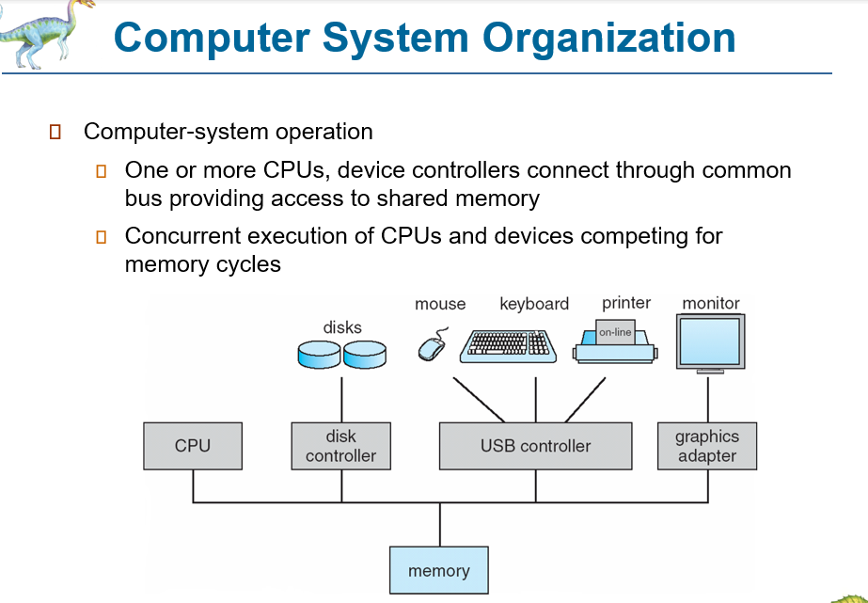

**What's your personal idea when we say os? Ano ang difference sng computer architecture sa computer organization?**

-when we are talking how a computer component works....we refer to **architecture.**....when we talk about how these components are connected, then we are talking about **organization**

**Computer-System Operation**

- what computing principle is behind the VON NEUMANN MACHINE?

- Input, process, output

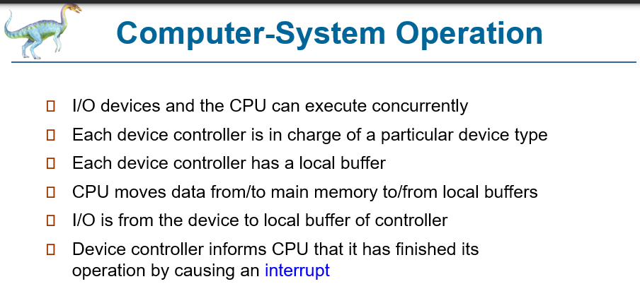

**Buffer**....what is this?

- ok...it's temporary storage...

- Buffer is a region of memory used to temporarily hold data while it is being moved from one place to another. A buffer is used when moving data between processes within a computer.

**RAM:**

-related to this is CACHE which will discuss soon

**Interrupt:**

- ang interrupt can be generated by a hardware or software

- when an interrupt is generated....it allows the CPU TO TEMPORARILY STOP ITS WORK and give attention to the interrupt

- tawag gani nga interrupt ky gina stop for a while

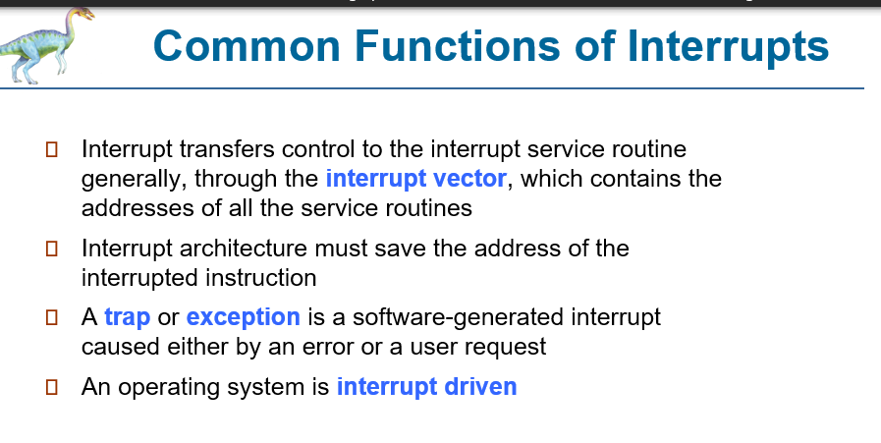

OS IS INTERRUPT DRIVEN

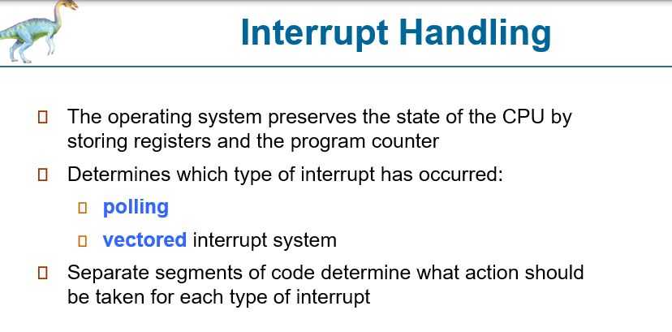

- meaning..during the interrupt, THE OS PRESERVE THE STATUS OF THE CPU, STORING SOME VALUES SOMEWHERE ELSE LIKE THE REGISTERS

- of course, action should be taken by the CPU based on the type of interrupt it received'

INPUT/OUTPUT STRUCTURE

